
Ten80 NSL Miami Invitational
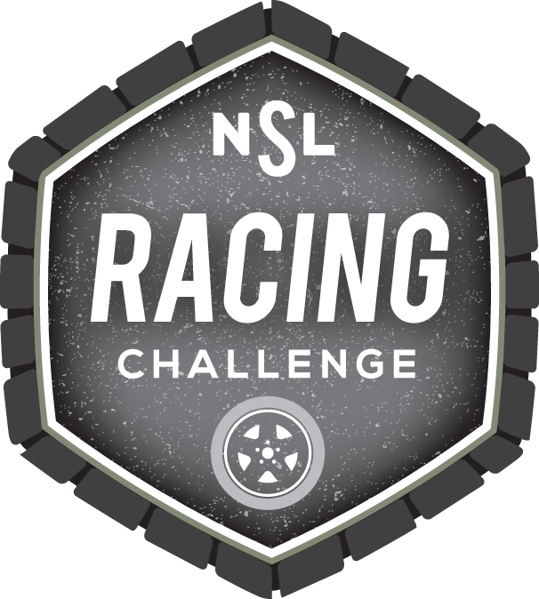
Registration Form
March 13, 2015
Venue: Homestead-Miami Speedway
1 Ralph Sanchez Speedway BLVD, Homestead, FL 33035
Mail to 26F Congress St #338
Saratoga Springs, NY 12866
Fax to 518-533-3804
Scan/Email to support@ten80education.com
Register Online: http://www.nationalstemleague.com/forms/invitational-registration-form/
Registration Deadline is February 19, 2015

School or Organization Information
School/Organization:
District or Parent Organization:
Street Address:
City: | State:

Team or Coach Main Contact Information
First Name: | Last Name:
Work Phone #: | Cell Phone #:
Email:
Field Trip Information
Number of Adult Chaperones: | Number of Teams/Students per Team:
Name Team 1: | Name Team 2 (optional):
Registration: 9:00 AM  Lunchtime ~12:30 PM. Departure: 1:00 PM | What time will you arrive?
Choose Your Events:
Data-Driven Design 5 Minute Most Laps 25 Minute Endurance 3 Minute Team Pitch Graphic Design

A Few Commitments to Hold Your Space
Check each box to indicate that you understand then sign and date below.
We commit to competing in the Carolinas Invitational at Homestead-Miami Speedway on March 13, 2015.
Ten80 requires each individual to bring a signed Ten80 waiver to the event. You commit to completing and returning this documentation

Chaperone Signature & Date:
Principal Signature & Date:

Participating School/Org:
Participant Name: |  |  |  | On-Site Chaperone
Participant Age: |  |  | Relation to Participant |  |  | € Self € Parent-Guardian
Parent / Guardian Name:
Home Address:
Emergency Daytime Phone |  |  |  |  | Home Phone
Email:
WAIVER AND RELEASE OF LIABILITY. In consideration of being permitted to participate in the Miami Invitational 2015 and related activities on Friday, March 13, 2015 at the Homestead-Miami Speedway, 1 Ralph Sanchez Speedway Boulevard, Homestead, FL 33035 (the “Event”), (“Participant”) or Participant’s parent or guardian agrees to the following on behalf of him or herself and heirs, successors and assigns.
I confirm that I have legal authority (a) over myself as a Participant having reached the legal age of 18, or (b) as a parent of or guardian for the Participant. I request that I / my child be permitted to participate in the Event. I, the Participant or Parent/Guardian of Participant agree that the Participant will follow all instructions of Event organizers and to assume all risks associated with a failure to follow instructions. The Participant will inspect the Event site, all related facilities, and all equipment and advise Event personnel of any unsafe conditions.
I, the Participant or Parent/Guardian of Participant, agree to release and discharge 1080 Education Inc. (“Sponsor”), Ten80 Foundation (“Sponsor”), U.S. Army (“Sponsor”), NHRA (“Sponsor”), Homestead-Miami Speedway (“Sponsor”), vendors and exhibitors and their respective affiliates, directors, employees, contractors, representatives and agents (“Released Parties”) from any and all injuries (fatal or non-fatal), losses, causes of action, liabilities, damages, expenses or claims (collectively, “Claims”), whether foreseeable or not, that might arise from the negligence of the Released Parties in connection with the Event or the condition of the property, facilities or equipment used for the Event, regardless of when such Claim may arise. I agree to indemnify, defend and hold harmless the Released Parties from and against any and all Claims arising from my/the Participant’s acts or omissions in connection with the Event.
I, the Participant or Parent/Guardian of the Participant, understand the Event may include hazardous activities including but not limited to riding in a car, bus or van at highway speeds and that this type of activity can be dangerous and can, and sometimes does, result in serious, permanent bodily injury (fatal or non-fatal). I also understand that my/the Participant’s participation in the Event may involve risks that may or may not be foreseeable and may expose me/the Participant to the possibility of injury as well as damage to personal property. I acknowledge that such hazards may result from my/the Participant’s own acts or omissions or those of others, the rules of play or the condition of the premises or equipment. I knowingly assume all risks associated with participation in the Event regardless of how such property damage, injury or death might arise. I understand that it is my responsibility to obtain any insurance needed to cover personal injury, death, property damage or any Claims arising from my/the Participant’s participation in the Event.
Video/Photo Release I, the Participant or Parent/Guardian of the Participant, hereby grants Sponsors the right to use the Participant’s name, likeness, voice, biographical information and any other indicia of his/her identity in connection with the Event, and publicity, advertising and promotion for the Event and future editions of the Event in all forms of media throughout the world in perpetuity without compensation. I waive any right that I, the Participant or Parent/Guardian of the Participant, may have to inspect or approve any materials that may use such rights in connection with the Event and any and all future uses. I acknowledge that Sponsors shall co-own with each other all rights to photos, video imagery, sounds or other recordings made in connection with the Event and any and all future uses.
MEDICAL AUTHORIZATION: I, the Participant or Parent/Guardian of the Participant, warrant that Participant has no physical condition which would interfere with the Participant’s ability to participate in or attend the Event or would endanger the Participant’s health or any other participant’s health. Should the Participant need to have medical treatment while participating in this event, I hereby give the Event Sponsors personnel permission to use their judgment in obtaining medical service for the Participant and I give permission to the physician selected by Sponsor(s) personnel to render medical treatment deemed necessary and appropriate by the physician. I understand that the Sponsors have no insurance covering such medical or hospital costs incurred for the Participant and, therefore, any costs incurred for such treatment shall be my sole responsibility.
This waiver and release will be construed broadly to provide a release and waiver to the maximum extent permissible under applicable law. This waiver and release shall be construed and interpreted in accordance with the laws of the Commonwealth of Massachusetts, excluding laws regarding conflicts of laws. Any provisions found to be void or unenforceable shall be modified or deleted to the minimum extent necessary to make them enforceable, and shall not affect the enforceability of any other provisions.
I have read this Waiver and Release of Liability, I fully understand its terms, and I recognize that I have given up rights by signing it in consideration of being permitted to participate in the event. I sign it voluntarily and without any inducement OR DURESS.
Signature: |  |  |  |  |  |  | Date:

